ABSTRACT

The increasing demand for reliable and efficient power distribution has led to the need for advanced fault detection systems in three-phase power networks. Traditional fault detection methods rely on manual inspection and SCADA-based monitoring, which can be slow and costly. This project proposes an IoT-based Three-Phase Fault Detection System to enhance real-time monitoring, quick fault diagnosis, and automated alerts.

The system consists of current and voltage sensors connected to a microcontroller, which continuously monitors the three-phase supply. When an abnormal condition such as overvoltage, undervoltage, overcurrent, or phase imbalance occurs, the system detects the fault and transmits the data to a cloud-based IoT platform. Users can access real-time information through a web or mobile application, enabling remote monitoring and quick decision-making. Additionally, the system can be programmed to trigger protective mechanisms, such as circuit breakers, to minimize damage.

This IoT-based fault detection system enhances grid reliability, reduces downtime, and improves maintenance efficiency by providing timely alerts and diagnostic insights. The integration of IoT ensures cost-effectiveness and scalability, making it suitable for smart grid applications.

Three-phase power systems are widely used in industries, power transmission, and distribution networks. However, faults such as short circuits, line-to-line faults, and line-to-ground faults can cause severe damage to electrical equipment and disrupt power supply. Detecting these faults in real-time is crucial for minimizing downtime and improving grid reliability.

The Internet of Things (IoT) offers a smart solution by enabling remote monitoring, real-time data transmission, and automated alerts. This project aims to develop an IoT-based fault detection system that continuously monitors the three-phase power supply and provides instant fault notifications.
CHAPTER 1
1.INTRODUCTION

  - Introduction: Transmission lines are vital for the effective distribution of electrical energy across vast distances. However, they are susceptible to various types of faults, which can lead to significant disruptions in service, equipment damage, and safety hazards. With an increasing reliance on power systems, it is essential to implement robust fault detection mechanisms. This paper explores the integration of Arduino and IoT technologies to develop a real-time fault detection system for overhead transmission lines, enhancing reliability and safety. This system integrates sensors, microcontrollers, and IoT technology to detect faults in the three-phase power supply. When a fault occurs, the system identifies the affected phase and sends alerts through wireless communication (such as Wi-Fi or GSM) to the relevant personnel. This allows for remote monitoring and quick corrective actions.

  - Problem Statement: The existing fault detection methods for transmission lines often suffer from delayed response times and lack of precise fault localization. With 85-87% of power system faults occurring in overhead lines, there is an urgent need for a system that can quickly identify not only the occurrence of a fault but also its exact location and type. This delay can lead to prolonged outages and increased operational costs, emphasizing the need for innovative solutions.

  - Problem Solution: To address these issues, we propose a fault detection system utilizing Arduino microcontrollers integrated with IoT capabilities. The system will continuously monitor the transmission line parameters and detect anomalies indicative of faults. Upon detection, the system will determine the fault location and type, displaying this information on a local screen and transmitting it to the control room for rapid response.

  - Key Features of the Solution: Object Detection and Distance Measurement: The ultrasonic sensor detects the object and measures the distance to it using time-of-flight principles. Servo Motor for 360-degree Scanning: The servo motor allows the ultrasonic sensor to rotate and cover a wide area for object detection. IoT Integration with Blynk: The ESP32 / ESP8266 / NodeMCU sends real-time data to the Blynk platform, allowing users to monitor object detection and distance on their mobile devices. Alerts and Notifications: The system can be configured to send notifications to the user when an object is detected within a certain distance range, enhancing security and surveillance applications.

  - Literature Survey: Traditional Methods: Discuss previous methodologies such as relay systems and impedance-based fault detection, highlighting their limitations in terms of speed and accuracy. Recent Advances: Review contemporary research on the use of smart sensors and IoT for monitoring transmission lines, emphasizing the benefits of real-time data transmission and analytics. Comparative Studies: Analyze studies that compare traditional fault detection methods with IoT-based solutions, showcasing improved efficiency and reliability.
A literacy survey helps assess the awareness, knowledge, and implementation of IoT-based three-phase fault detection systems among professionals, industries, and students. The survey aims to identify the level of understanding, adoption challenges, and potential improvements in fault detection technology.
Survey Objectives:
1. Assess Awareness: Understand how well individuals and organizations are aware of IoT-based fault detection.
2. Evaluate Knowledge: Identify the level of technical understanding regarding IoT, sensors, and microcontrollers used in fault detection.
3. Determine Adoption Rates: Explore how many industries or power grids have implemented such systems.
4. Identify Challenges: Highlight barriers to adoption, such as cost, technical expertise, or infrastructure limitations.
5. Collect Feedback for Improvement: Gather suggestions to enhance fault detection efficiency and reliability.

CHAPTER 2
2.BLOCK DIAGRAM & CIRCUIT DIAGRAM

2.1 Block Diagram
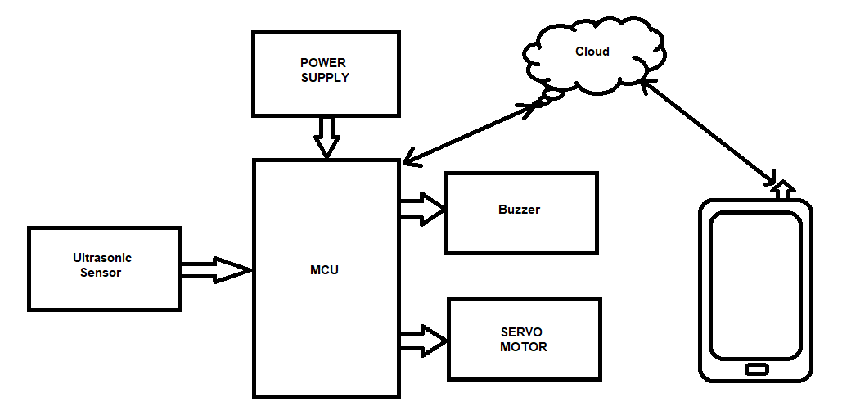

2.2 Circuit Diagram

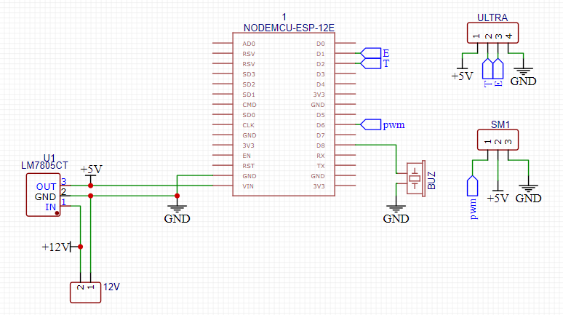

CHAPTER 3
3.COMPONENTS & ITS SPECIFICATIONS
3.1 ESP32s:
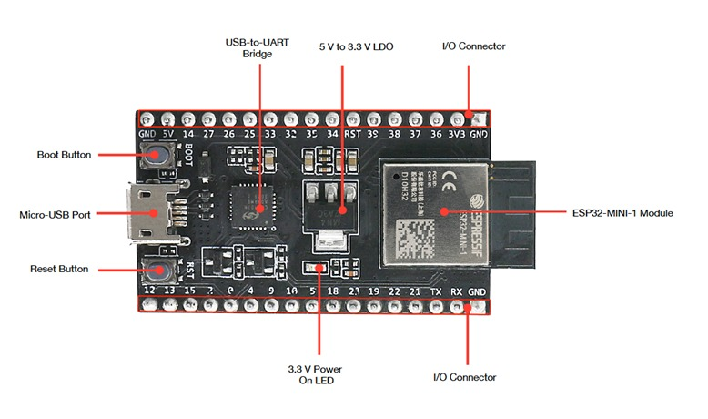
Fig 1. ESP32
The ESP32 is a low-power micro-controller that uses Wi-Fi and Bluetooth to connect devices to networks. It’s often used in IoT applications. The ESP32 can connect to other devices and networks, and exchange data in real time.
SPECIFICATIONS:
1.32-bit microprocessor
2.Memory-448 KB ROM, 520 KB SRAM
3.Input-34 GPIOs
4.Clock Frequency up to 240MHZ
5.Lower Power Consumption

3.2 LM2596:

The LM2596 is used in circuits primarily as a step-down voltage regulator(also known as a buck convertor),allowing you to efficiently convert a higher input voltage to a lower, regulated output voltage.
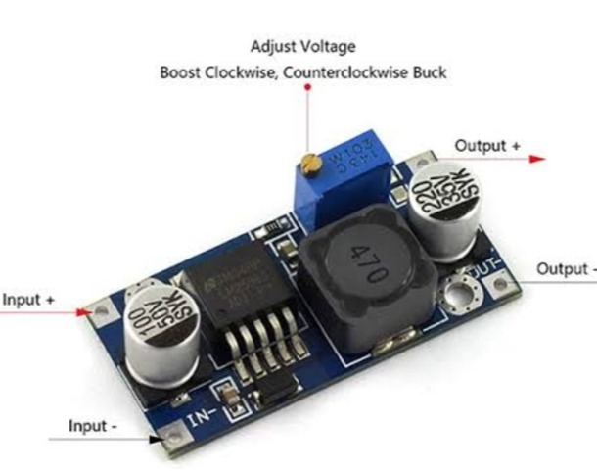

Fig 2. LM2596

SPECIFICATIONS:
- Input Voltage: 4.75-35V
- Output Voltage: 1.25 - 26V or 1.5 - 35V (Adjustable)
- Conversion Efficiency: Up to 92% or up to ~93%
- Switching Frequency: 150kHz
- Operating temperature: -45 to +85 degrees Celsius

3.3 TACT SWITCH:
A tact switch is a puh-button switch that completes an electrical circuit when pressed. The switch provides tactile feedback when pressed, such as a click or bump.
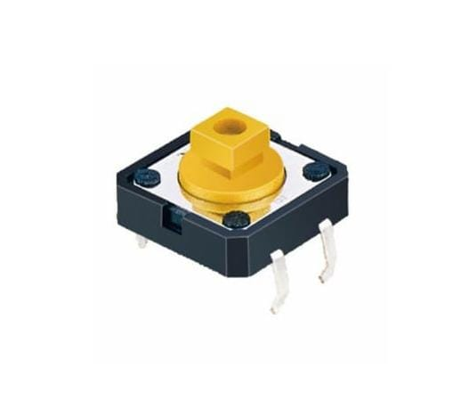

Fig 3. Tact Switch
SPECIFICATIONS:
- Rating: 50mA, 12VDC
- Contact Resistance: 50m ohms
- Insulation Resistance: 100M ohms
- Electrically Life: >100000cycles
- Operating Force: 180/250(+- 30gf)

3.4 JUMPED WIRES:
It Creates temporary connections between different components in an electronic circuit, typically on a bread- board or during prototyping. Essentially acting as a “bridge” to connect different parts of a circuit quickly and easily.

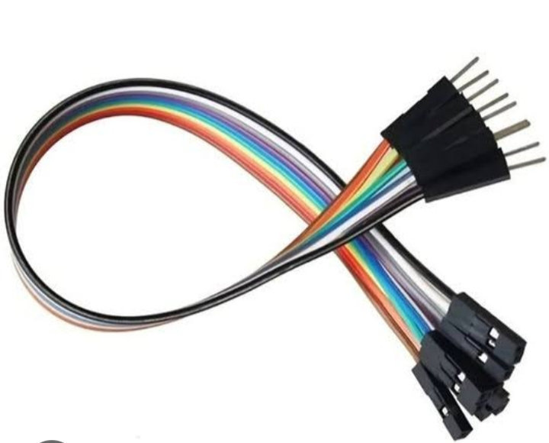

Fig 4. Jumped Wires

SPECIFICATIONS:
- Wire Gauge: Uses 26 AWG or 28 AWG
- Conductor Material: Copper
- Insulation Material: PVC (polyvinyl chloride)
- Pin Pitch: 2.54mm
- Length: Typically between 10cm and 20cm

CHAPTER 4
4.SOFTWARE & INSTALLATION PROCEDURE

4.1 About Arduino IDE and its features
The Arduino IDE is an open-source software, which is used to write and upload code to the Arduino boards. The IDE application is suitable for different operating systems such as Windows, Mac OS X, and Linux. It supports the programming languages C and C++. Here, IDE stands for Integrated Development Environment.
The program or code written in the Arduino IDE is often called as sketching. We can connect Arduino board / ESP32 / ESP8266 / NodeMCU with the IDE to upload the sketch written in the Arduino IDE software. The sketch is saved with the extension '.ino '
The Arduino IDE will appear as in Fig 5:

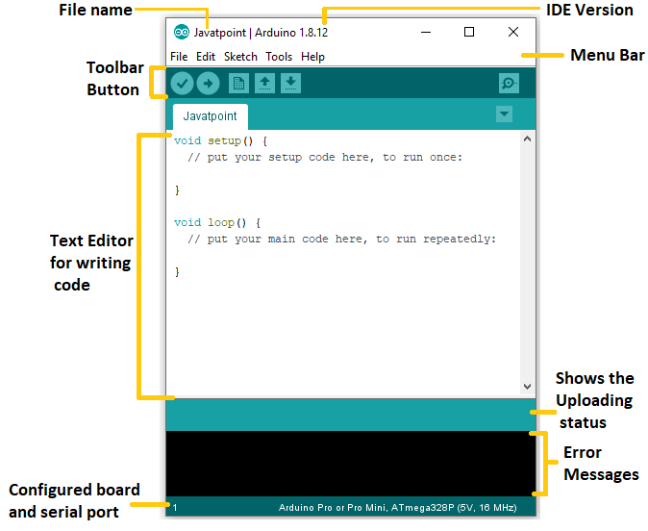
Fig 5. Arduino IDE Screen

Each section of the Arduino IDE display is detailed below.
Toolbar Button
The icons displayed on the toolbar are New, Open, Save, Upload, and Verify.
It is shown below:
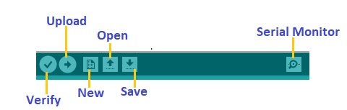
Upload
The Upload button compiles and runs our code written on the screen. It further uploads the code to the connected board. Before uploading the sketch, we need to make sure that the correct board and ports are selected.
We also need a USB connection to connect the board and the computer. Once all the above measures are done, click on the Upload button present on the toolbar.
The latest Arduino boards can be reset automatically before beginning with Upload. In the older boards / certain ESP32 MCU, we need to press the Reset button present on it. As soon as the uploading is done successfully, we can notice the execution of the program example: The Blink of the LED.
If the uploading is failed, it will display the message in the error window.
We do not require any additional hardware to upload our sketch using the Arduino Bootloader.
A Bootloader is defined as a small program, which is loaded in the microcontroller present on the board.
Open
The Open button is used to open the already created file. The selected file will be opened in the current window.
Save
The save button is used to save the current sketch or code.
New
It is used to create a new sketch or opens a new window.
Verify
The Verify button is used to check the compilation error of the sketch or the written code.
Serial Monitor
The serial monitor button is present on the right corner of the toolbar. It opens the serial monitor.
It is shown below:
:
When we connect the serial monitor, the board will reset on the operating system Windows, Linux, and Mac OS X. If we want to process the control characters in our sketch, we need to use an external terminal program. The terminal program should be connected to the COM port, which will be assigned when we connect the board to the computer.
Menu Bar in IDE
File Menu
When we click on the File button on the Menu bar, a drop-down list will appear. It is shown below:
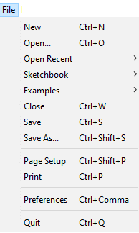
Let's discuss each option in detail.
New
The New button opens the new window. It does not remove the sketch which is already present.
Open
It allows opening the sketch, which can be browsed from the folders and computer drivers.
Open Recent
The Open Recent button contains the list of the recent sketches.
Sketchbook
It stores the current sketches created in the Arduino IDE software. It opens the selected sketch or code in a new editor at an instance.
Examples
It shows the different examples of small projects for a better understanding of the IDE and the board. The IDE provides examples of self-practice.
Close
The Close button closes the window from which the button is clicked.
Save
The save button is used to save the current sketch. It also saves the changes made to the current sketch. If we have not specified the name of the file, it will open the 'Save As...' window.
Save As
We can save the sketch with a different name using the 'Save As...' button. We can also change the name accordingly.
Page Setup
It allows setting the page margins, orientation, and size for printing. The 'Page Setup' window will appear as:
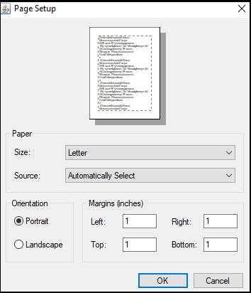

Print
According to the settings specified in the 'Page Setup', it prepares the current sketch for printing.
Preferences
It allows the customization settings of the Arduino IDE.
Quit
The Quit button is used to close all the IDE windows. The same closed sketch will be reopened when we will open the Arduino IDE.
Edit Menu
When we click on the Edit button on the Menu bar, a drop-down list appears. It is shown below:
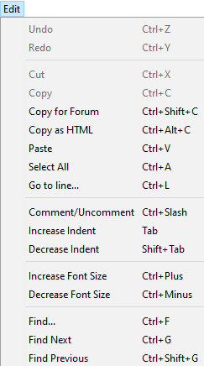

Let's discuss each option in detail
Undo
The Undo button is used to reverse the last modification done to the sketch while editing.
Redo
The Redo button is used to repeat the last modification done to the sketch while editing.
Cut
It allows us to remove the selected text from the written code. The text is further placed to the clipboard. We can also paste that text anywhere in our sketch.
Copy
It creates a duplicate copy of the selected text. The text is further placed on the clipboard.
Copy for Forum
The 'Copy for Forum' button is used to copy the selected text to the clipboard, which is also suitable for posting to the forum.

Copy as HTML
The 'Copy for Forum' button is used to copy the selected text as HTML to the clipboard. It is desirable for embedding in web pages.
Paste
The Paste button is used to paste the selected text of the clipboard to the specified position of the cursor.
Select All
It selects all the text of the sketch.
Go to line
It moves the cursor to the specified line number.
The window will appear as:
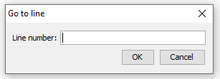

Comment/Decomment
The Comment/ Decomment button is used to put or remove the comment mark (//) at the beginning of the specified line.
Increase Indent
It is used to add the space at the starting of the specified line. The spacing moves the text towards the right.
Decrease Indent
It is used to subtract or remove the space at the starting of the specified line. The spacing moves the text towards the left.
Increase Font Size
It increases the font size of the written text.
Decrease Font Size
It decreases the font size of the written text.
Find
It is used to find the specified text. We can also replace the text. It highlights the text in the sketch.
The window will appear as:
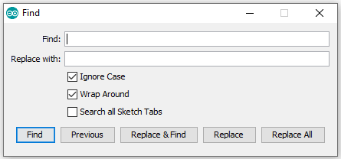
Find Next
It highlights the next word, which has specified in the 'Find...' window. If there is no such word, it will not show any highlighted text.
Find Previous
It highlights the previous word, which has specified in the 'Find' window. If there is no such word, it will not show any highlighted text.
Sketch Menu
When we click on the Sketch button on the Menu bar, a drop-down list appears. It is shown below:
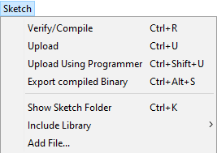
Let's discuss each option in detail.
Verify/Compile
It will check for the errors in the code while compiling. The memory in the console area is also reported by the IDE.

Upload
The Upload button is used to configure the code to the specified board through the port.

Upload Using Programmer
It is used to override the Bootloader that is present on the board. We can utilize the full capacity of the Flash memory using the 'Upload Using Programmer' option. To implement this, we need to restore the Bootloader using the Tools-> Burn Bootloader option to upload it to the USB serial port.

Export compiled Binary
It allows saving a .hex file and can be kept archived. Using other tools, .hex file can also be sent to the board.

Show Sketch Folder
It opens the folder of the current code written or sketch.

Include Library
Include Library includes various Arduino libraries. The libraries are inserted into our code at the beginning of the code starting with the #. We can also import the libraries from .zip file.

Add File...
The Add File... button is used to add the created file in a new tab on the existing file.
For example, let's add 'Blink' file to the 'Javatpoint' file. The tab will now appear as:
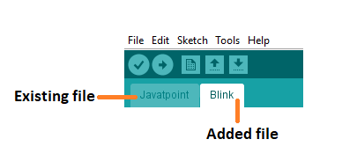

Tools Menu
When we click on the Tools button on the Menu bar, a drop-down list appears. It is shown below:
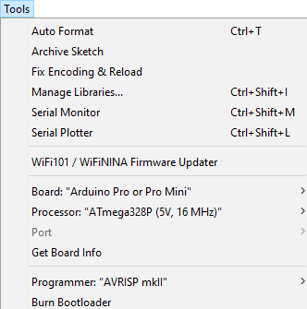
Let's discuss each option in detail.
Auto Format
The Auto Format button is used to format the written code. For example, lining the open and closed curly brackets in the code.
Archive Sketch
The copy of the current sketch or code is archived in the .zip format. The directory of the archived is same as the sketch.
Fix Encoding and Reload
This button is used to fix the inconsistency between the operating system char maps and editor char map encoding.
Manage Libraries...
It shows the updated list of all the installed libraries. We can also use this option to install a new library into the Arduino IDE.
Serial Monitor
It allows the exchange of data with the connected board on the port.
Serial Plotter
The Serial Plotter button is used to display the serial data in a plot. It comes preinstalled in the Arduino IDE.
WiFi101/WiFiNINA Firmware Updater
It is used to check and update the Wi-Fi Firmware of the connected board.
Board
We are required to select the board from the list of boards. The selected board must be similar to the board connected to the computer.
Processor
It displays the processor according to the selected board. It refreshes every time during the selection of the board.
Port
It consists of the virtual and real serial devices present on our machine.
Get Board Info
It gives the information about the selected board. We need to select the appropriate port before getting information about the board.
Programmer
We need to select the hardware programmer while programming the board. It is required when we are not using the onboard USB serial connection. It is also required during the burning of the Bootloader.
Burn Bootloader
The Bootloader is present on the board onto the microcontroller. The option is useful when we have purchased the microcontroller without the bootloader. Before burning the bootloader, we need to make sure about the correct selected board and port.
Help Menu
When we click on the Help button on the Menu bar, a drop-down list will appear. It is shown below:
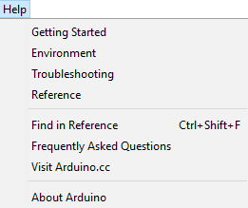
The Help section includes several documents that are easy to access, which comes along with the Arduino IDE. It consists of the number of options such as Getting Started, Environment, Troubleshooting, Reference, etc. can be accessed without the internet connection as well. It will directly link us to the official website of Arduino.

4.2 Why Arduino IDE?
1. Easy to use: Arduino IDE provides a user-friendly interface for writing, compiling, and uploading code.
2. Cross-platform: Available for Windows, macOS, and Linux.
3. Open source: Free to download, modify, and distribute.
4. Large community: Extensive libraries, tutorials, and forums.
5. Versatile: Supports various microcontrollers, including Arduino, ESP32, and ESP8266.

4.3 Why Arduino IDE for ESP32/ESP8266?
1. Simplified development: Arduino IDE streamlines the development process for ESP32/ESP8266.
2. Library support: Access to a vast library collection, including WiFi, Bluetooth, and IoT-specific libraries.
3. Community resources: Leverage ESP32/ESP8266-specific tutorials, examples, and forums.
4. Easy uploading: Upload code directly from Arduino IDE to ESP32/ESP8266 boards.
5. Cost-effective: No need for expensive development tools or software.

ESP32-specific benefits:
1. Dual-core processing: Arduino IDE supports ESP32's dual-core architecture.
2. Wi-Fi and Bluetooth: Easily integrate Wi-Fi and Bluetooth capabilities.
3. Low-power consumption: Optimize power usage with Arduino IDE's built-in features.
4. Advanced peripherals: Access ESP32's advanced peripherals, such as SPI, I2C, and UART.

ESP8266-specific benefits:
1. WiFi integration: Easily integrate WiFi capabilities.
2. Low-cost: ESP8266 is an affordable board.
3. Small footprint: Ideal for IoT projects requiring compact design.
4. Community support: Extensive ESP8266 community and resources.
Comparison with other IDEs:
1. Platform IO: More complex but offers advanced features and multi-platform support.
2. Visual Studio Code: More versatile but requires additional setup and configuration.
3. ESP-IDF: Official ESP32/ESP8266 IDE, but steeper learning curve.
Arduino IDE provides an ideal balance of ease, versatility, and community support, making it a popular choice for ESP32 and ESP8266 development.
4.4 Step by Step Installation Procedure
In this section, we will learn in easy steps, how to set up the Arduino IDE on our computer and prepare the board to receive the program via USB cable.
The Arduino IDE 2 is an open-source project. It is a big step from its sturdy predecessor, Arduino IDE 1.x, and comes with revamped UI, improved board & library manager, debugger, autocomplete feature and much more.
Step 1 – Download and install the Arduino IDE 2 on your Windows. You can easily download the editor by visit the Arduino Software page: https://www.arduino.cc/en/software
Requirements
- Windows - Win 10 and newer, 64 bits
- Linux - 64 bits
- macOS - Version 10.15: "Catalina" or newer, 64 bits
For windows installation: In Arduino IDE 2.3.3 select Win 10 and newer, 64 bits

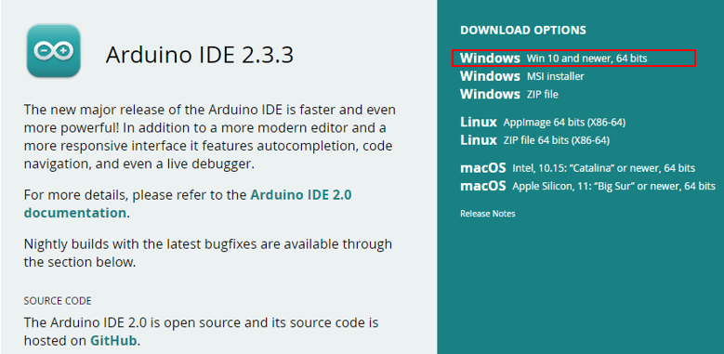
Fig 6. Arduino Software page

To install the Arduino IDE 2 on a Windows computer, simply run the file downloaded from the software page.

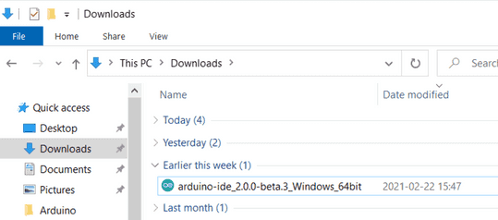
Fig 7. Running the Executable Arduino IDE 2 installation file

Follow the instructions in the installation guide as shown in the image. The installation may take several minutes.
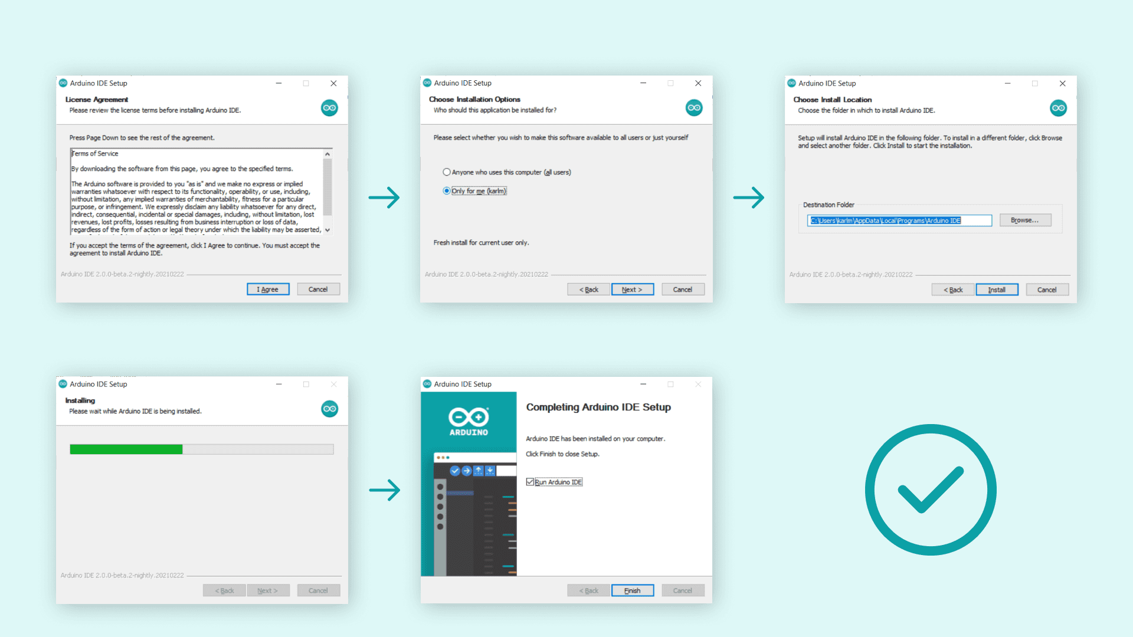

Installing ESP32 Board in Arduino IDE 2
Before proceeding make sure you have completed above process that is Arduino IDE 2 installed on your computer and follow the instructions given below

Install ESP32 Add-on in Arduino IDE
To install the ESP32 board in your Arduino IDE, follow these next instructions:
1. In your Arduino IDE 2, go to File > Preferences.
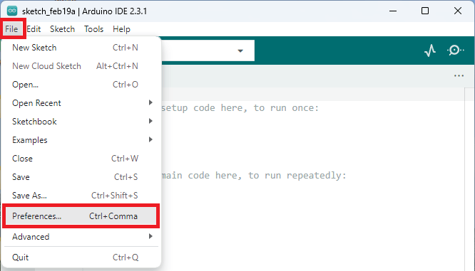
2. Copy and paste the following line to the Additional Boards Manager URLs field.
https://raw.githubusercontent.com/espressif/arduino-esp32/gh-pages/package_esp32_index.json
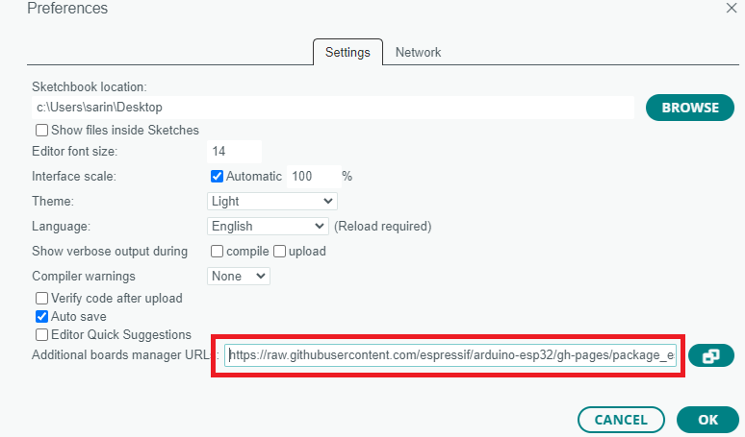
Note: if you already have the ESP8266 boards URL, you can separate the URLs with a comma, as follows:
http://arduino.esp8266.com/stable/package_esp8266com_index.json,
https://raw.githubusercontent.com/espressif/arduino-esp32/gh-pages/package_esp32_index.json

3. Open the Boards Manager. You can go to Tools > Board > Boards Manager… or you
can simply click the Boards Manager icon in the left-side corner.
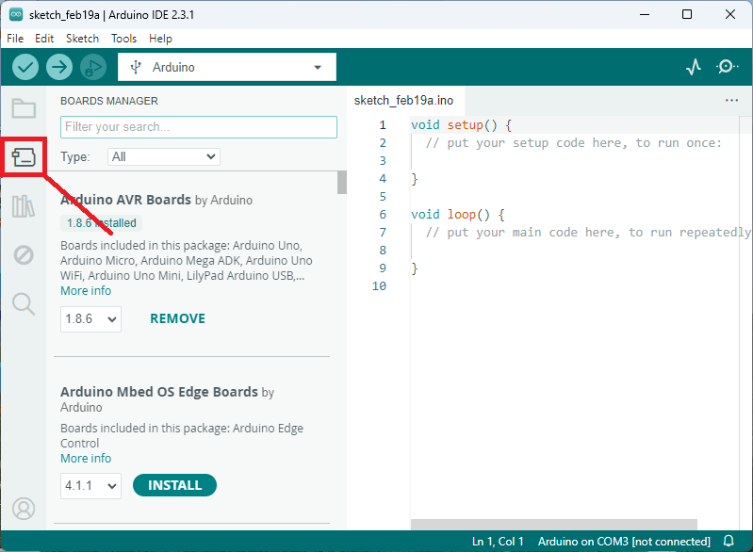
4. Search for ESP32 and press install button for esp32 by Espress if Systems version 3.X.
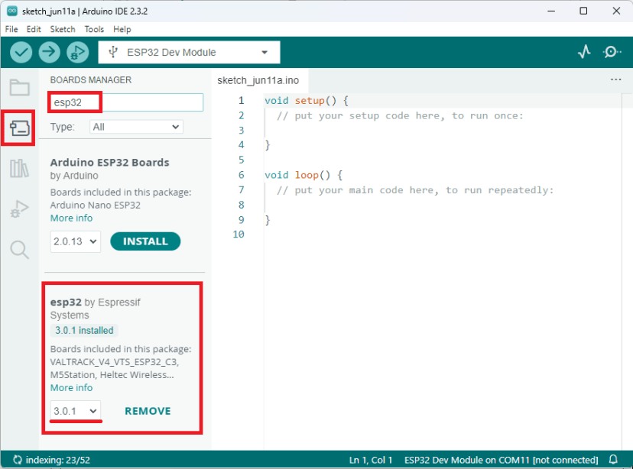
That’s it. It should be installed after a few seconds.

Testing the Installation
To test the ESP32 add-on installation, upload a simple code that blinks the on-board LED (GPIO 2).
Write the following code to your Arduino IDE:
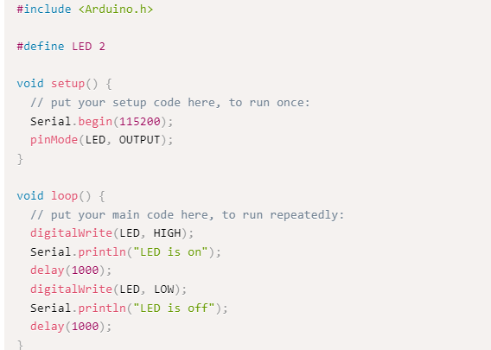
Uploading the Sketch
Select your board before uploading the code. On the top drop-down menu, click on “Select other board and port…”
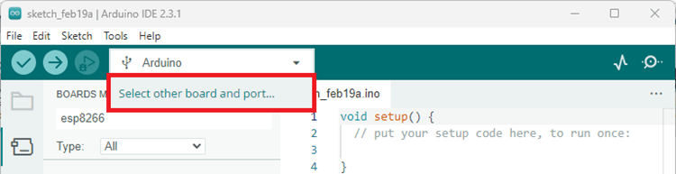

Uploading the Sketch
Select your board before uploading the code. On the top drop-down menu, click on “Select other board and port…”

A new window, as shown below, will open. Search for your ESP32 board model.
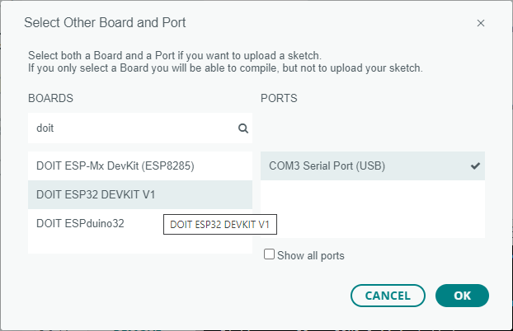
Select the ESP32 board model you’re using, and the COM port. In our example, we’re using the DOIT ESP32 DEVKIT V1. Click OK when you’re done.
Now, you just need to click on the Upload button shown below.

After a few seconds, the upload should be complete.
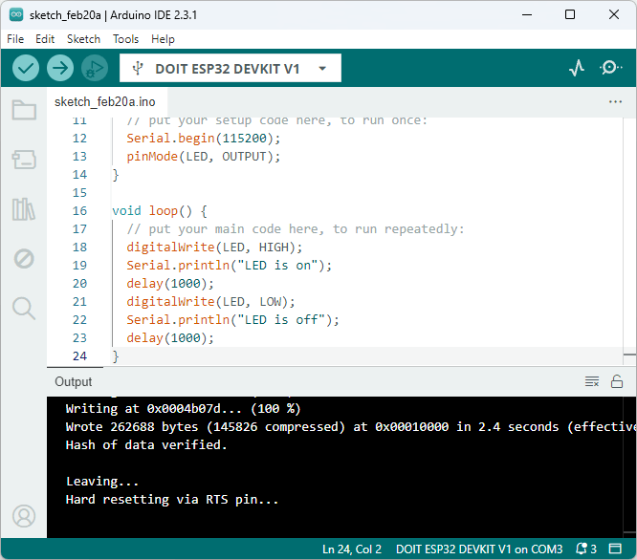
Note: some ESP32 development boards don’t go into flashing/uploading mode automatically when uploading a new code and you’ll see a lot of dots on the debugging window followed by an error message. If that’s the case, you need to press the ESP32 BOOT button when you start seeing the dots on the debugging window.
The ESP32 on-board LED should be blinking every second.

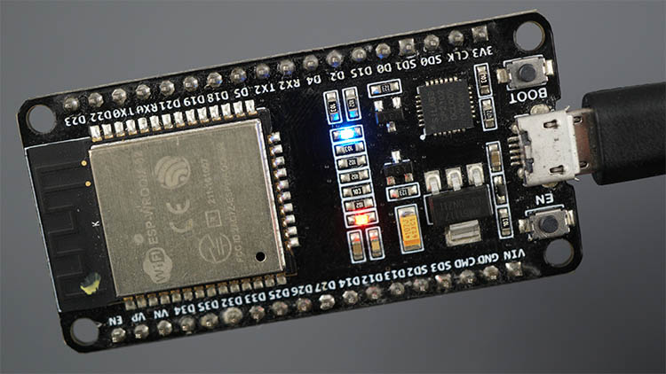

Serial Monitor
You can click on the Serial Monitor icon to open the Serial Monitor tab. Make sure you select the 115200 baud rate.

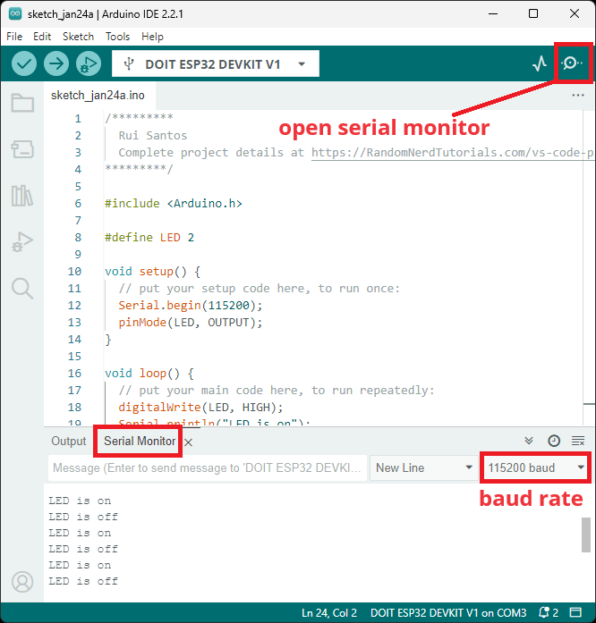
That’s it! You’ve installed the ESP32 Boards successfully in Arduino IDE 2.

Troubleshooting
If you try to upload a new sketch to your ESP32 and you get this error message “A fatal error occurred: Failed to connect to ESP32: Timed out… Connecting…”. It means that your ESP32 is not in flashing/uploading mode.
Having the right board name and COM port selected, follow these steps:

- Hold-down the BOOT button in your ESP32 board
- Press the Upload button in the Arduino IDE to upload your sketch
- After you see the “Connecting….” message in your Arduino IDE, release the finger from the BOOT button
- After that, you should see the “Done uploading” message
Installing Libraries
Libraries are a collection of code that makes it easy for you to connect to a sensor, display, module, etc. For example, the LiquidCrystal library makes it easy to talk to character LCD displays. There are thousands of libraries available for download directly through the Arduino IDE, and you can find all of them listed at the Arduino Library Reference.

Using the Library Manager
To install a new library into your Arduino IDE you can use the Library Manager (available from IDE version 1.6.2). Open the IDE and click to the "Sketch" menu and then Include Library > Manage Libraries.
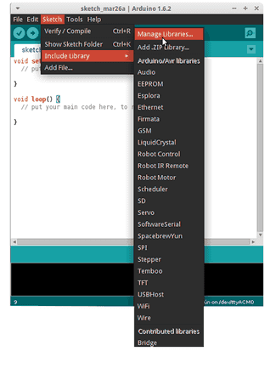
Then the Library Manager will open, and you will find a list of libraries that are already installed or ready for installation. In this example we will install the Bridge library. Scroll the list to find it, click on it, then select the version of the library you want to install. Sometimes only one version of the library is available. If the version selection menu does not appear, don't worry it is normal.
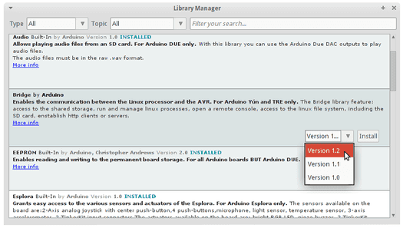
Finally click on install and wait for the IDE to install the new library. Downloading may take time depending on your connection speed. Once it has finished, an Installed tag should appear next to the Bridge library. You can close the library manager.
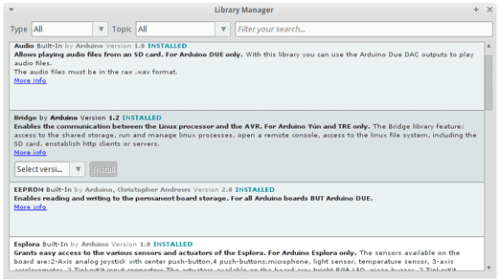
You can now find the new library available in the Sketch > Include Library menu. If you want to add your own library to Library Manager, follow these instructions.
Importing a .zip Library
Libraries are often distributed as a ZIP file or folder. The name of the folder is the name of the library. Inside the folder will be a .cpp file, a .h file and often a keywords.txt file, examples folder, and other files required by the library. Starting with version 1.0.5, you can install 3rd party libraries in the IDE. Do not unzip the downloaded library, leave it as is.

In the Arduino IDE, navigate to Sketch > Include Library > Add .ZIP Library. At the top of the drop-down list, select the option to "Add .ZIP Library''.

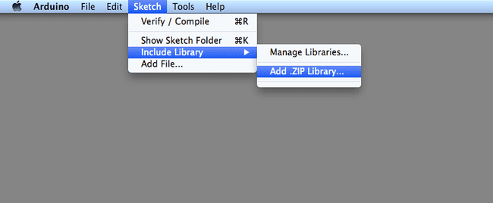
You will be prompted to select the library you would like to add. Navigate to the .zip file's location and open it.
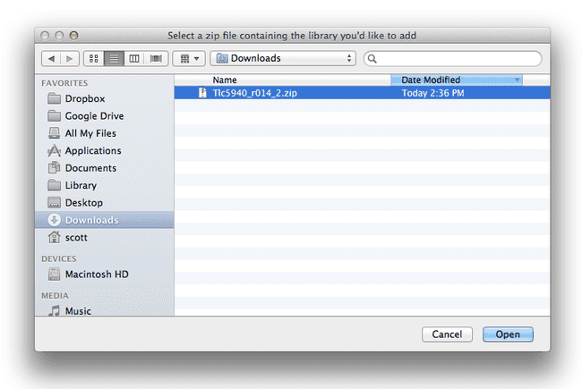
Return to the Sketch > Include Library menu. menu. You should now see the library at the bottom of the drop-down menu. It is ready to be used in your sketch. The zip file will have been expanded in the libraries folder in your Arduino sketches directory.
Note: the library will be available to use in sketches, but with older IDE versions examples for the library will not be exposed in the File > Examples until after the IDE has restarted.

Manual Installation
When you want to add a library manually, you need to download it as a ZIP file, expand it and put in the proper directory. The ZIP file contains all you need, including usage examples if the author has provided them. The library manager is designed to install this ZIP file automatically as explained in the former chapter, but there are cases where you may want to perform the installation process manually and put the library in the libraries folder of your sketchbook by yourself.
You can find or change the location of your sketchbook folder at File > Preferences > Sketchbook location.
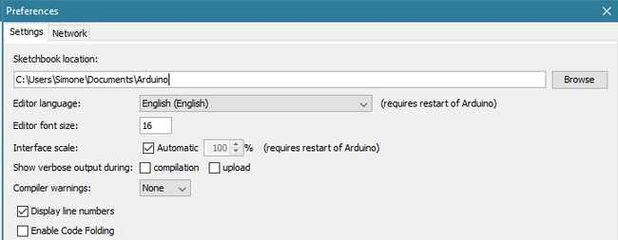
Go to the directory where you have downloaded the ZIP file of the library
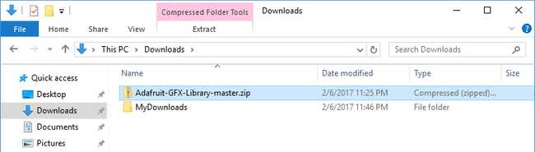
Extract the ZIP file with all its folder structure in a temporary folder, then select the main folder, that should have the library name
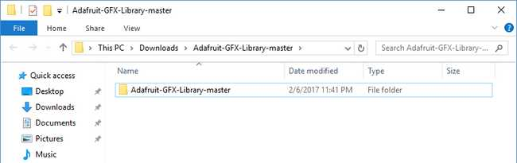
Copy it in the "libraries" folder inside your sketchbook.

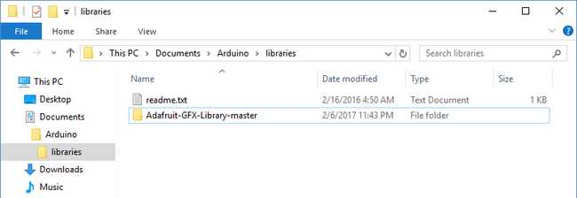

Start the Arduino Software (IDE), go to Sketch > Include Library. Verify that the library you just added is available in the list.

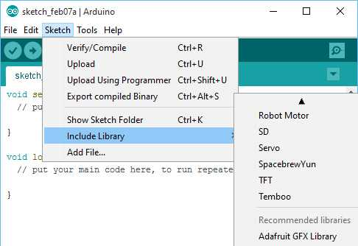

Please note: Arduino libraries are managed in three different places: inside the IDE installation folder, inside the core folder and in the libraries folder inside your sketchbook. The way libraries are chosen during compilation is designed to allow the update of libraries present in the distribution. This means that placing a library in the "libraries" folder in your sketchbook overrides the other libraries versions.

4.5 Blynk Library Installation
To install a new library Blynk into your Arduino IDE, you can use the Library Manager.
First, connect your computer o the Internet. Open the IDE and click to the “Sketch” menu and then Include Library > Manage Libraries.
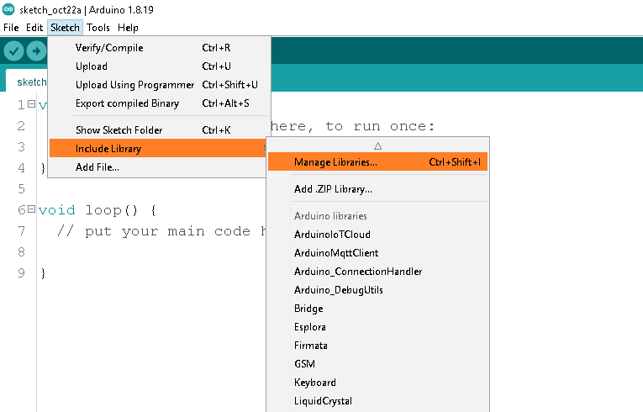
Then the Library Manager will open and you will find a list of libraries that are already installed or ready for installation. Search for Blynk library and in the version selection choose the latest version to date.
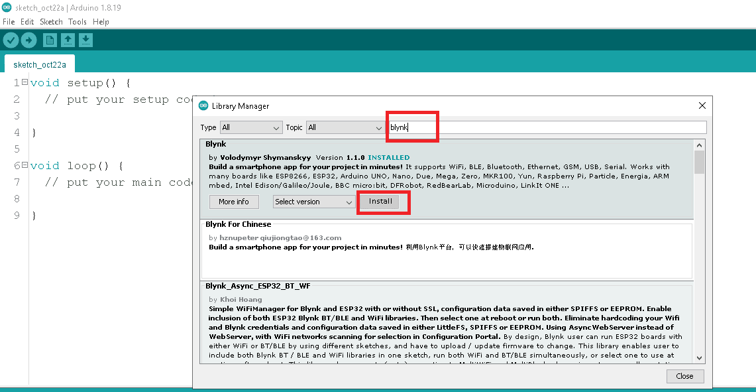
Finally click on Install and wait for the IDE to install the new library. Downloading may take time depending on your connection speed. Once it has finished, an Installed tag should appear next to the Bridge library. You can close the library manager.
CHAPTER 5
5.IOT CLOUD & SERVER PLATFORM

What is the internet of things (IoT)?
The internet of things, or IoT, is a network of interrelated devices that connect and exchange data with other IoT devices and the cloud. IoT devices are typically embedded with technology such as sensors and software and can include mechanical and digital machines and consumer objects.
These devices encompass everything from everyday household items to complex industrial tools. Increasingly, organizations in a variety of industries are using IoT to operate more efficiently, deliver enhanced customer service, improve decision-making and increase the value of the business.
With IoT, data is transferable over a network without requiring human-to-human or human-to-computer interactions.
A thing in the internet of things can be a person with a heart monitor implant, a farm animal with a biochip transponder, an automobile that has built-in sensors to alert the driver when tire pressure is low, or any other natural or man-made object that can be assigned an Internet Protocol address and can transfer data over a network.

How does IoT work?
IoT systems function by gathering data from sensors embedded in IoT devices, which is then transmitted through an IoT gateway for analysis by an application or back-end system
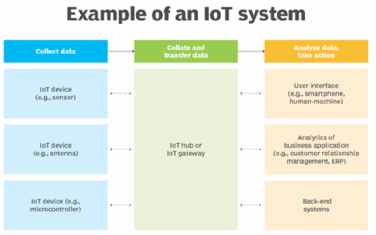

The following four elements are incorporated into an IoT ecosystem for it to function:

Sensors or devices
An IoT ecosystem consists of web-enabled smart devices that use embedded systems, such as processors, sensors and communication hardware to collect, send and act on data acquired from their environments.

Connectivity
IoT devices can communicate with one another through a network over the internet. These devices share sensor data by connecting to an IoT gateway, which acts as a central hub where IoT devices can send data. Before the data is shared, it can also be sent to an edge device where it is analyzed locally.

Data analysis
Only the relevant data is used to identify patterns, offer recommendations and identify potential issues before they escalate. Analyzing data locally reduces the volume of data sent to the cloud, which minimizes bandwidth consumption.
Sometimes, these devices communicate with other related devices and act on the information they get from one another. The devices do most of the work without human intervention, although people can interact with the devices. For example, they can set them up, give them instructions or access the data. The connectivity, networking and communication protocols used with these web-enabled devices largely depend on the specific IoT applications deployed.
IoT can also use artificial intelligence and machine learning to make data collection processes easier and more dynamic.

Graphical user interface
A graphical user interface (UI) is typically used to manage IoT devices. For example, a website or a mobile app can be used as an UI to manage, control and register smart devices.
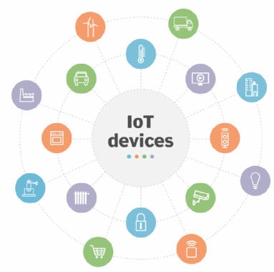

Consumer, enterprise and industrial IoT devices include smart TVs and smart sensors outfitted for conference rooms and assembly line machines.

IoT applications include the following:
- Agriculture. IoT can benefit farmers by making their jobs easier. For example, sensors can collect data on rainfall, humidity, temperature and soil content and IoT can help automate farming techniques. Additionally, IoT devices can be used to oversee the health of livestock, monitor equipment and streamline supply chain management.
- Construction. IoT can help monitor operations surrounding infrastructure. Sensors, for example, can monitor events or changes within structural buildings, bridges and other infrastructure that could potentially compromise safety. This provides benefits such as improved incident management and response, reduced operations costs and improved service quality.
- Home automation. A home automation business can use IoT to monitor and manipulate mechanical and electrical systems in a building. Homeowners can also remotely control and automate their home environment by using IoT devices, including smart thermostats, lighting systems, security cameras and voice assistants such as Alexa and Siri for increased comfort and energy efficiency.
- Smart buildings and cities. Smart cities can help citizens reduce waste and energy consumption. They can reduce energy costs using sensors that detect how many occupants are in a room and turning the air conditioner on if sensors detect a conference room is full or lowering the heat if everyone in the office has gone home.
- Urban consumption systems. IoT technologies can also be used to monitor and manage urban consumption such as traffic lights, parking meters, waste management systems and public transportation networks.
- Healthcare monitoring. IoT devices such as remote patient monitoring systems, smart medical devices and medication trackers let healthcare providers monitor patients' health status, manage chronic conditions and provide timely interventions. IoT gives providers the ability to monitor patients more closely by analyzing the generated data. Hospitals also often use IoT systems to complete tasks such as inventory management for both pharmaceuticals and medical instruments.
- Retail. IoT sensors and beacons in retail stores can track customer movement, analyze shopping patterns, manage inventory levels and personalize marketing messages. This enhances the shopping experience for customers and optimizes store operations.
- Transportation. IoT devices help the transportation industry by monitoring vehicle performance, optimizing routes and tracking shipments. For example, the fuel efficiency of connected cars can be monitored to reduce fuel costs and improve sustainability. IoT devices can also monitor the condition of cargo, so it reaches its destination in optimal condition.
- Wearable devices. Wearable devices with sensors and software can collect and analyze user data, sending messages to other technologies about the users to make their lives easier and more comfortable. Wearable devices are also used for public safety -- for example, by improving first responders' response times during emergencies by providing optimized routes to a location or by tracking construction workers' or firefighters' vital signs at life-threatening sites.
- Energy management. IoT-enabled smart grids, smart meters and energy management systems let utility companies and consumers monitor and optimize energy usage, manage demand-response programs and integrate renewable energy sources more efficiently. For example, the data collected by the IoT devices and sensors helps identify patterns, peak usage times and areas of inefficiency.

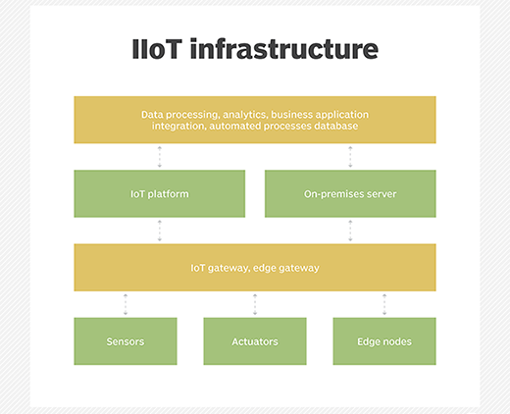

What Is IoT Cloud?
An IoT cloud is a massive network that supports IoT devices and applications. This includes the underlying infrastructure, servers and storage, needed for real-time operations and processing. An IoT cloud also includes the services and standards necessary for connecting, managing, and securing different IoT devices and applications.

Why IoT Cloud?
IoT clouds offer an efficient, flexible, and scalable model for delivering the infrastructure and services needed to power IoT devices and applications for businesses with limited resources. IoT clouds offer on-demand, cost-efficient hyperscale so organizations can leverage the significant potential of IoT without having to build the underlying infrastructure and services from scratch.
Servers
Servers in IoT connect physical devices to the internet, allowing them to communicate and share data. They can be used to monitor and control devices remotely, and to allow devices to interact with each other autonomously.

Here are some types of servers used in IoT:
- IoT Data Server
A data integration controller that can be used in factories, production lines, and cloud systems. It has standard data management functions for collection, processing, saving, noticing, and publishing.
- IoT web server
A platform that connects devices to the internet, allowing them to communicate and share data. It can be used to monitor and control devices remotely, and to allow devices to interact with each other autonomously.
- Windows Server IoT
A full version of Windows Server that provides enterprise manageability and security to IoT solutions.
- Embedded web server
A small, lightweight web server that can be integrated into other software or hardware systems. It's used to provide a web-based interface for monitoring and controlling devices.
- Network server
A server that plays a crucial role in IoT ecosystems by managing network resources and device communications. It allows IoT networks to scale up to support thousands or even millions of devices.

Message Queue Telemetry Transport Protocol (MQTT)
Message Queuing Telemetry Transport, or MQTT, is a communications protocol designed for Internet of Things devices with extremely high latency and restricted low bandwidth. Message Queuing Telemetry Transport is a perfect protocol for machine-to-machine (M2M) communication since it is designed specifically for low-bandwidth, high-latency settings.
What is Message Queue Telemetry Transport Protocol (MQTT)?
MQTT is a simple, lightweight messaging protocol used to establish communication between multiple devices. It is a TCP-based protocol relying on the publish-subscribe model. This communication protocol is suitable for transmitting data between resource-constrained devices having low bandwidth and low power requirements. Hence this messaging protocol is widely used for communication in the IoT Framework.

Publish-Subscribe Model
This model involves multiple clients interacting with each other, without having any direct connection established between them. All clients communicate with other clients only via a third party known as a Broker.
MQTT Client and Broker
Clients publish messages on different topics to brokers. The broker is the central server that receives these messages and filters them based on their topics. It then sends these messages to respective clients that have subscribed to those different topics. The heart of any publish/subscribe protocol is the MQTT broker. A broker can handle up to thousands of concurrently connected MQTT customers, depending on how it is implemented. All communications must be received by the broker, who will then sort them, ascertain who subscribed to each one, and deliver the messages to the clients who have subscribed. All persistent customers’ sessions, including missed messages and subscriptions, are likewise kept by the Broker.
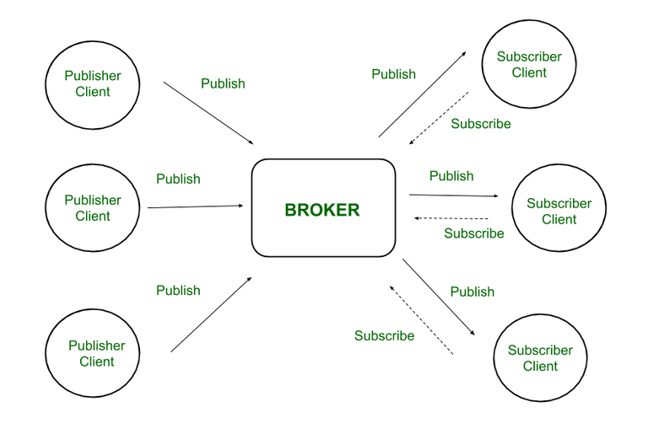
Fig. Publish-Subscribe Model

Hence client that has subscribed to a specific topic receives all messages published on that topic.
Here the broker is central hub that receives messages, filters them, and distributes them to appropriate clients, such that both message publishers, as well as subscribers, are clients.

Working of MQTT
MQTT’s publish/subscribe (pub/sub) communication style, which aims to maximise available bandwidth, is an alternative to conventional client-server architecture that communicates directly with an endpoint. In contrast, the client who transmits the message (the publisher) and the client or clients who receive it (the subscribers) are not connected in the pub/sub paradigm. Third parties—the brokers—manage the relationships between the publishers and subscribers because they don’t communicate with one another directly.
Publishers and subscribers, which denote whether a client is publishing messages or has subscribed to receive messages, are examples of MQTT clients. The same MQTT client can be used to accomplish these two features. A publish occurs when a client or device want to submit data to a server or broker.
The term “subscribe” refers to the reversal of the procedure. Several clients can connect to a broker under the pub/sub paradigm and subscribe to subjects that interest them.
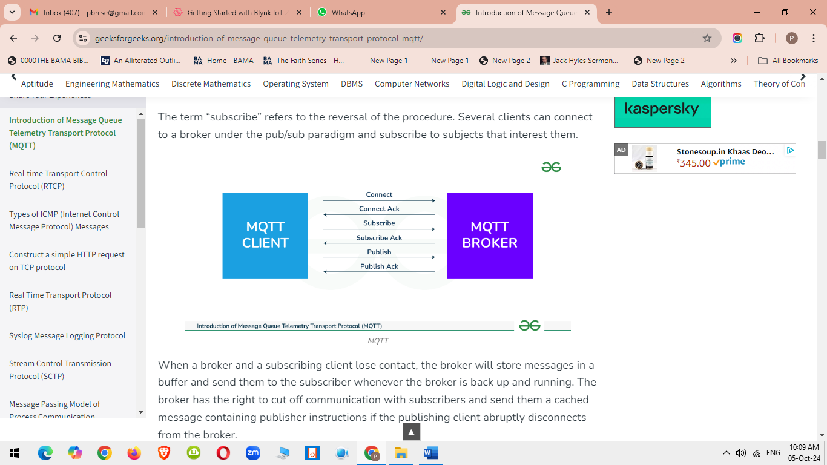

When a broker and a subscribing client lose contact, the broker will store messages in a buffer and send them to the subscriber whenever the broker is back up and running. The broker has the right to cut off communication with subscribers and send them a cached message containing publisher instructions if the publishing client abruptly disconnects from the broker.
“Publishers send the messages, subscribers receive the messages they are interested in, and brokers pass the messages from the publishers to the subscribers,” reads an IBM write-up describing the pub/sub paradigm. MQTT clients, such as publishers and subscribers, can only speak with MQTT brokers. Any device or programme that runs a MQTT library can be a MQTT client, ranging from microcontrollers like the Arduino to entire application servers housed in the cloud.
Characteristics of MQTT
- Lightweight: MQTT is designed to be lightweight, making it suitable for use in aid-restrained environments inclusive of embedded systems and low-strength devices. The protocol minimizes bandwidth and processing overhead, enabling green communication even on restricted networks.
- Publish-Subscribe Model: In the publish-subscribe version, clients (publishers) send messages to subjects, and different clients (subscribers) acquire messages from subjects of interest. This decoupling of producers and purchasers permits for flexible and dynamic conversation styles.
- Quality of Service (QoS) Levels: MQTT supports exclusive stages of message delivery warranty, referred to as Quality of Service (QoS). QoS levels range from 0 to 2, providing various stages of reliability and message transport guarantees, relying at the utility necessities.
- Retained Messages: MQTT lets in agents to store retained messages on topics, making sure that new subscribers acquire the maximum latest message posted on a subject right now after subscribing. This characteristic is beneficial for fame updates and configuration settings.
- Last Will and Testament (LWT): MQTT clients can specify a Last Will and Testament message to be posted by way of the broker in the occasion of an sudden consumer disconnect. This function affords a mechanism for detecting patron failures and dealing with them gracefully.
- Security: MQTT helps various protection mechanisms, consisting of Transport Layer Security (TLS) encryption and authentication mechanisms which include username/password and consumer certificates. These capabilities make certain the confidentiality, integrity, and authenticity of messages exchanged over MQTT connections.
Advantages of MQTT
This model is not restricted to one-to-one communication between clients. Although the publisher client sends a single message on specific topic, broker sends multiple messages to all different clients subscribed to that topic. Similarly, messages sent by multiple such publisher clients on multiple different topics will be sent to all multiple clients subscribed to those topics. Hence one-to-many, many-to-one, as well as many-to-many communication is possible using this model. Also, clients can publish data and at the same time receive data due to this two-way communication protocol. Hence MQTT is considered to be bi-directional protocol. The default unencrypted MQTT port used for data transmission is 1883. The encrypted port for secure transmission is 8883.
- Lightweight protocol that is quick to create and allows for efficient data transport
- Minimal data packet usage, resulting in low network usage
- Effective data dispersion
- The effective use of remote sensing and control
- Prompt and effective message delivery
- Minimizes power consumption, which is beneficial for the linked devices, and maximizes network capacity.
- Data transmission is quick, efficient, and lightweight because MQTT messages have small code footprint. These control messages have a fixed header of size 2 bytes and payload message up to size 256 megabytes.

Introduction about Blynk IoT
Blynk is a software platform that allows users to connect their hardware to the cloud and manage connected devices remotely. Blynk is designed for the Internet of Things (IoT) and can be used for personal projects or commercial products.
Here are some features of Blynk:
- No-code approach: Blynk allows users to build and scale IoT without coding. For example, users can control an LED or motor from their phone with just a few clicks.
- Remote management: Users can remotely control devices from anywhere, receive notifications, and analyze data.
- Multi-tenancy: Users can configure roles and permissions to control who has access to data.
- Scalability: Blynk can handle thousands of devices and is used by businesses of all sizes.
- Open-source: Blynk's server is open-source and can be run locally or on Blynk Cloud.
- Blynk App: Users can create interfaces for their projects using widgets.
- Blynk Libraries: Users can communicate with the server and process commands for popular hardware platforms.
Blynk is free for personal use and prototyping. Businesses can purchase subscriptions to publish Blynk-powered apps for their products.

Setup Blynk 2.0 App
Step 1: Go to the Blynk website and click the "Sign Up" button. Enter your email address and create a password.
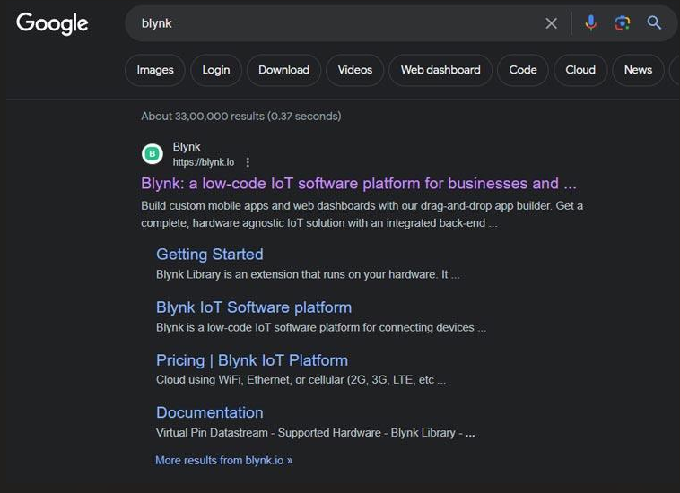

Step 2: Once you have signed up on the Blynk and logged in, tap the "+ New Template" button to create a new template.
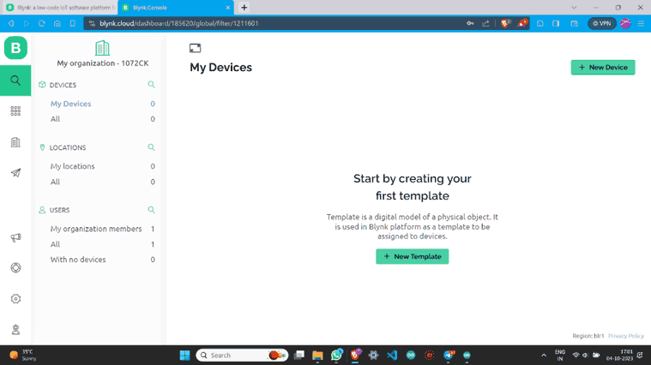

Step 3: Name the template, select the Development Board, set WiFi as the connection type and then save this template.

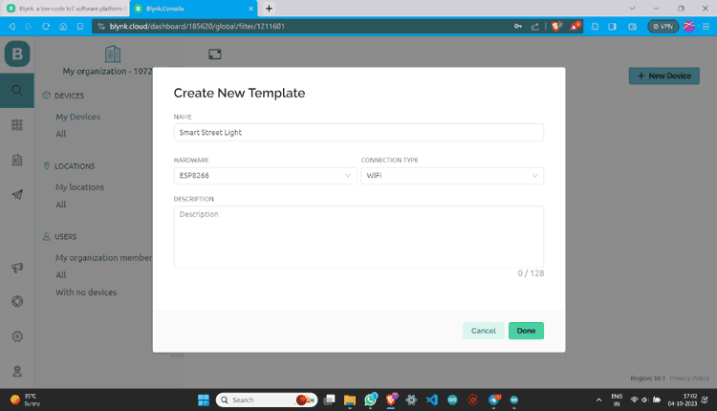

Step 4: Once a new template is created you will see the below screen on your blynk account.
.
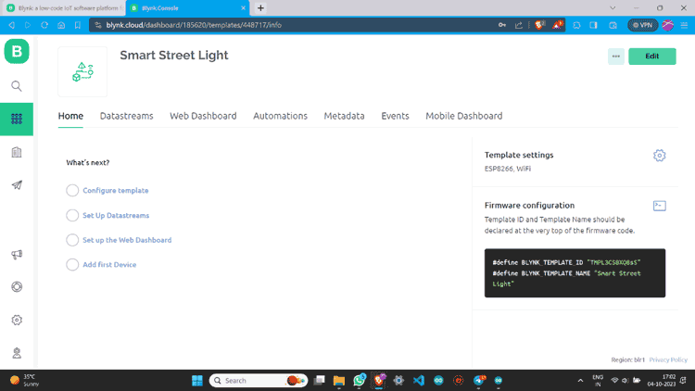

Step 5: Go to Datastreams and click on “+ New Datastream”. Then Choose “Digital Pin”.

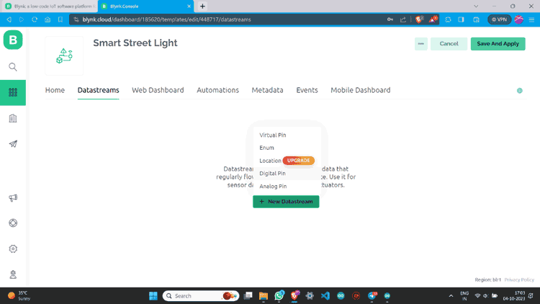

Step 6: Name Datastream and select pin. Assign it’s PIN MODE as Output and Create.

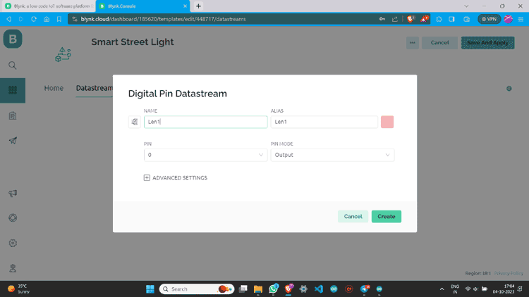

Step 7: Once a datastream is created on the blynk website, it will look something like this below

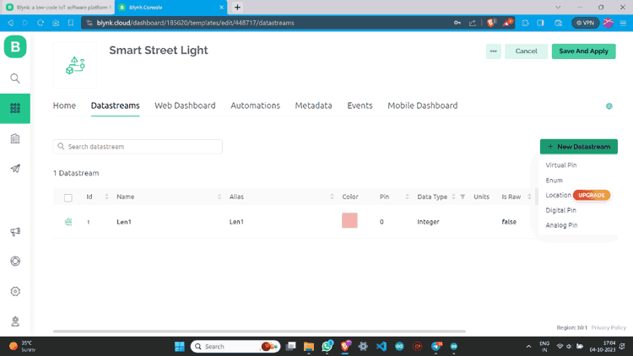

Step 8: I have made one more data stream with the same values.

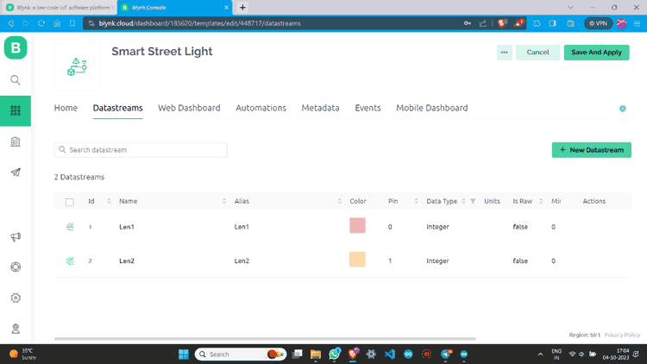

Step 9: Go to “Web Dashboard” and add Switch widgets.

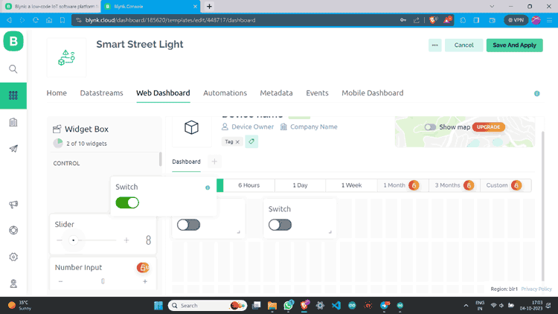

Step 10: Click on the Gear button, give values according to your choice, and save.

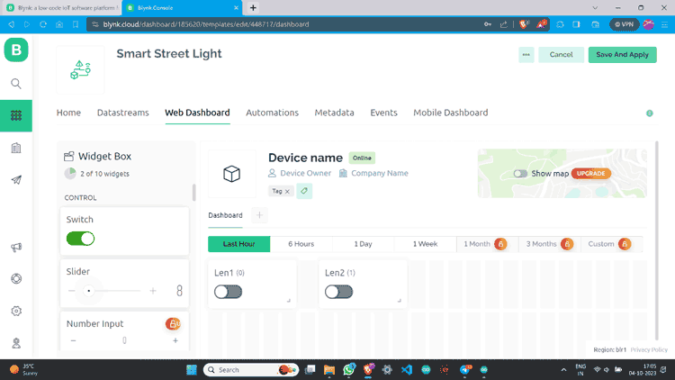

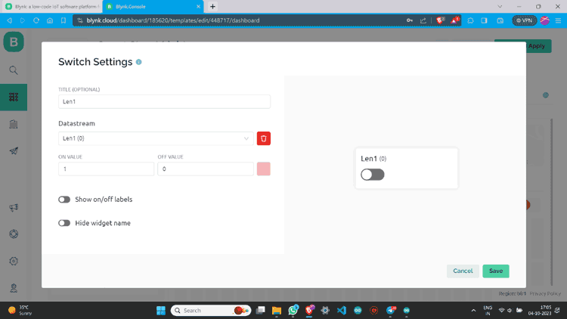

Step 11: I have made one more switch and assigned all values.

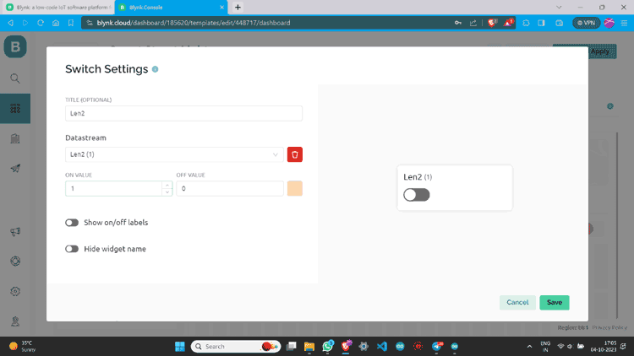

Step 12: Go to the lens icon and click on “+ New Device”.

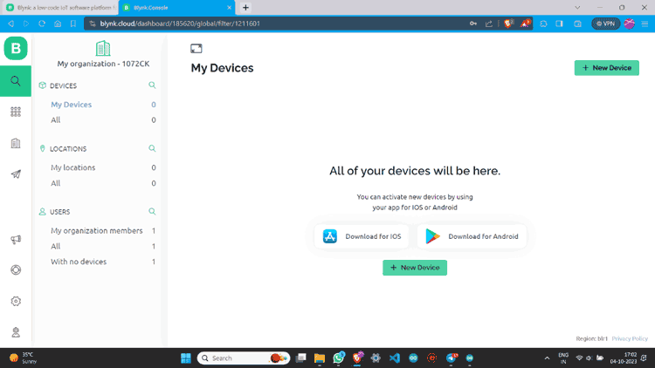

Step 13: Click “From template”, select the template, and create.

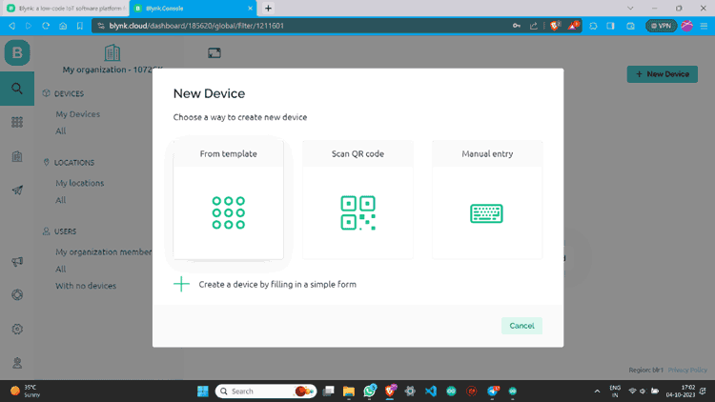

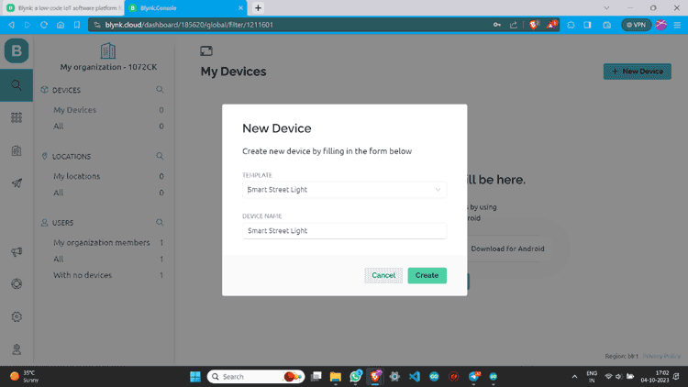

Step 14: Now you can see the device. Click on “Device Info” and copy the Auth Token.

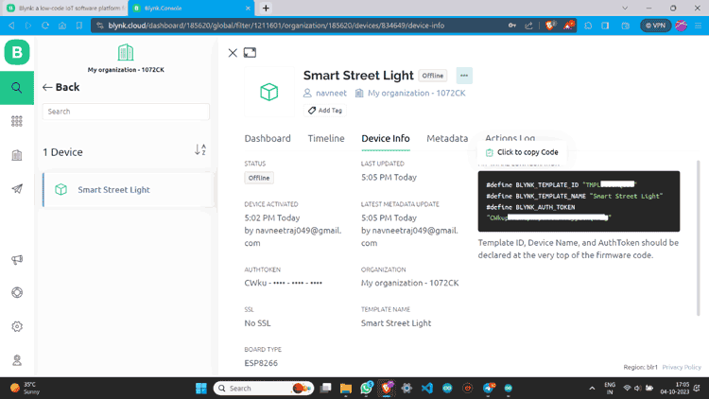Blynk 2.0 Application Setup
Now after Web setup, we have to make a Mobile App Interface so that we can able to control it from any Android or IOS
Step 1: Download the Blynk app.
The Blynk app is available for both IOS and Android devices. You can download the app from the App Store or Google Play.
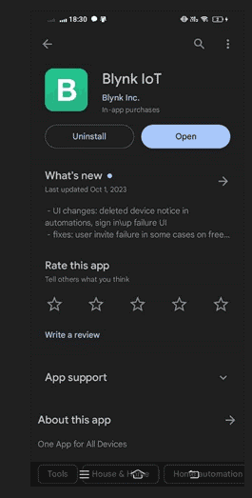
Step 2: Now open the Blynk IOT app and Log in with the credentials.
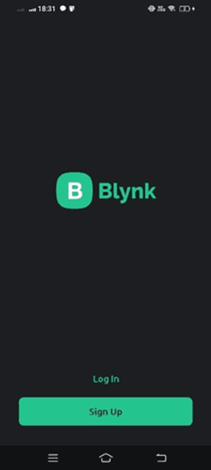

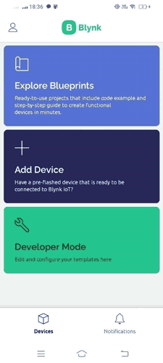
Step 3: After logging in click on “Add Device”.

Step 4: Click “Manually from template”, select the device we already created, and then create.

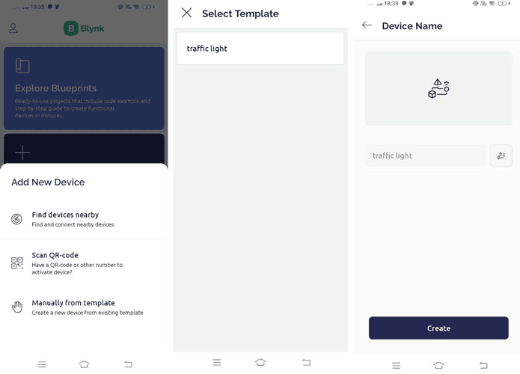

Step 5: Now you are on the dashboard of the device then click on the tool button to enter in Developer Mode.
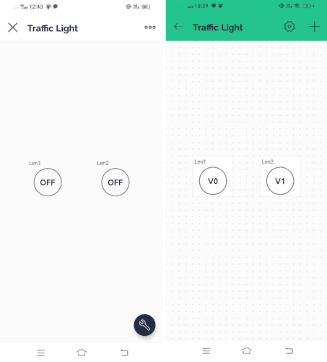
Step 6: Click on the button icons to assign values like Datastream and Mode. You can also change its design and looks.
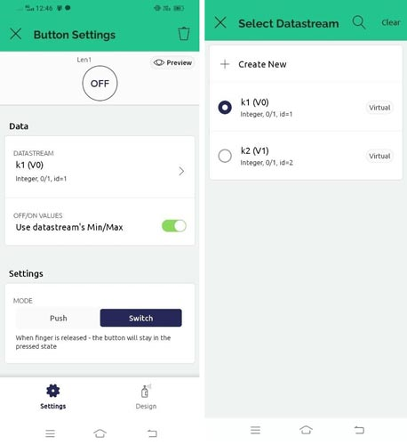
Step 7: You Have successfully created a device dashboard.
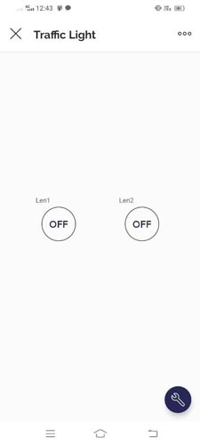
Step 8: You can check the device status also.
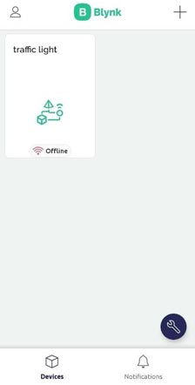

Setup Arduino IDE to NodeMCU ESP8266 board to use Blynk
Now we have to set our Arduino IDE to program the NodeMCU ESP8266 board.
Step 1: In Arduino IDE go to the “BOARDS MANAGER” and install ESP8266.

Install Blynk Library in Arduino IDE
to set our Arduino IDE to program the NodeMCU ESP8266 board.

Step 1: In Arduino IDE go to the “BOARDS MANAGER” and install ESP8266.
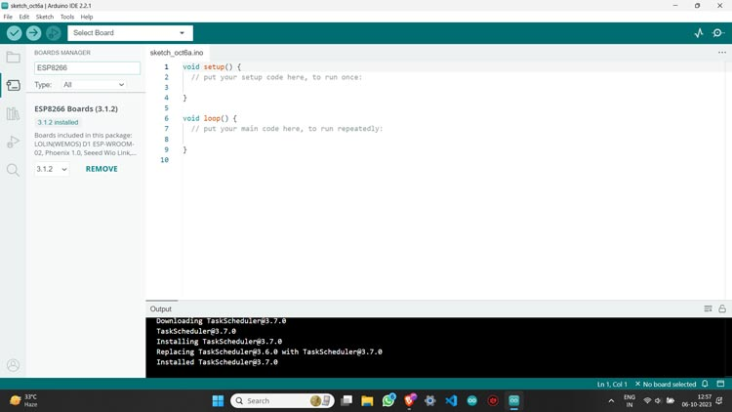

Step 2: Then go to the “LIBRARY MANAGER” and install the Blynk library.
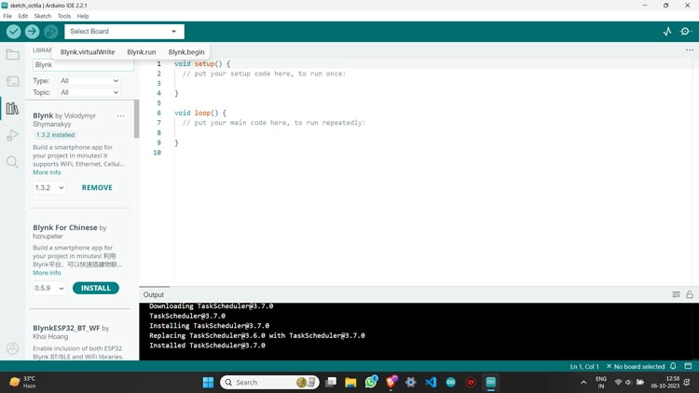
Step 3: Plug your NodeMCU ESP8266 board into the PC using a USB cable and then select your board and port.

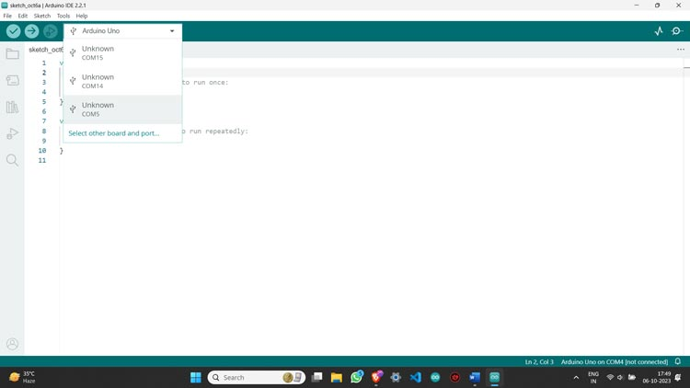

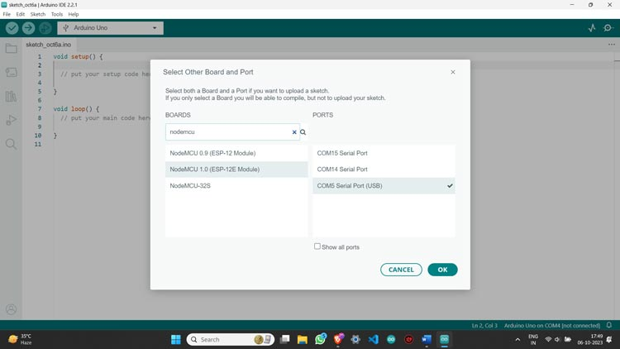

Step 4: Your Arduino IDE is now ready to program your board for using Blynk app

CHAPTER 6
- WORKING PRINCIPAL OF IDEATION
6.1 Tell about Project Working Processes: At first by the converter circuit, we are converting the voltage from 220v AC to 5v. Then we have to connect the internet to the system through the Wi-Fi module. Here we can monitor the system by using mobile application. Voltage source in a circuit may have fluctuations is not providing fixed voltage output so we use voltage regulation for IC “AMS1117” to maintain our output voltage 3.3v. Although operating voltage of NODEMCU is 3.3v. We work on a system that need three different type of voltage and that’s why we use voltage regulator and we make the voltage regulator by using a series connected four quantities of diode. We know that silicon diode saturated value is 0.7v. and our output voltage is3.3v. when we connected diode to our output voltage then we get value from diode.
D4: 3.3v-(0.7v-0.7v-0.7v-0.7v) =0.5v;
D3: 3.3v-0.7v=2.6v; D2: 3.3v-(0.v7-0.7v) =1.9v;
D1: 3.3v-(0.7v-0.7v-0.7) =1.2v;
Now we get four different voltage and we take three of them D3=2.6v, D2=1.9v and D1=1.2v.
Here is a NODEMCU that we use contains only one analog input pin, but our three-phase transmission line system has three input that’s why we used three Relay and it takes reading from three of the transmission lines for 1 second pulse and it continue the previous loop. We know that NODEMCU analog pin (A0) input value is 3.3v but it happens in a different way, when NODEMCU get 0 to 3.3v then its value is 0 to 1024. We define that when we input D3 voltage 2.6v then Arduino catch the value is 850- 1000 D2 voltage.
1.9v then Arduino catch value is 550-650 D1 voltage 1.2 v then Arduino catch value is 400-500 If there is no voltage then its value is 0-100. Through the relay D1, D2 D3 value is go to the NODEMCU Analog pin. Then we measure the all of value and we understand that what line is short circuit or what line is grounded and we see the load variation and we also see the fault by our mobile application using internet.
CHAPTER 7
7. OUTPUT & RESULTS

7.1 Project Photos

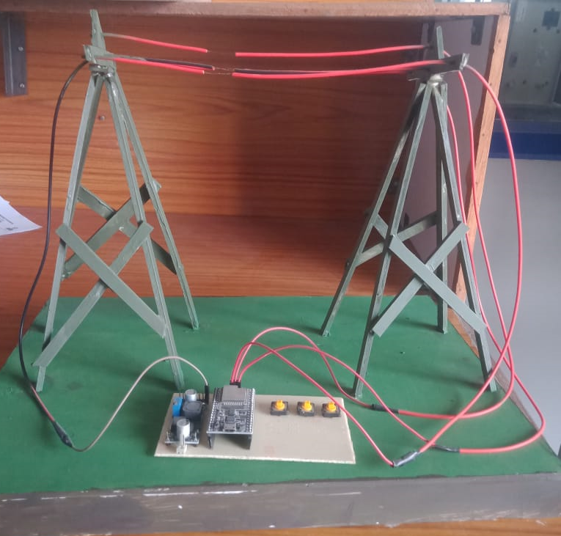

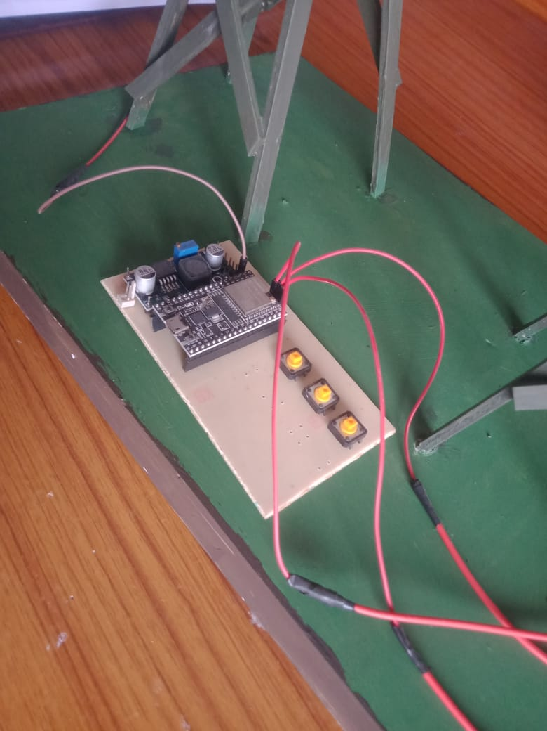

7.2 Screenshots of Results

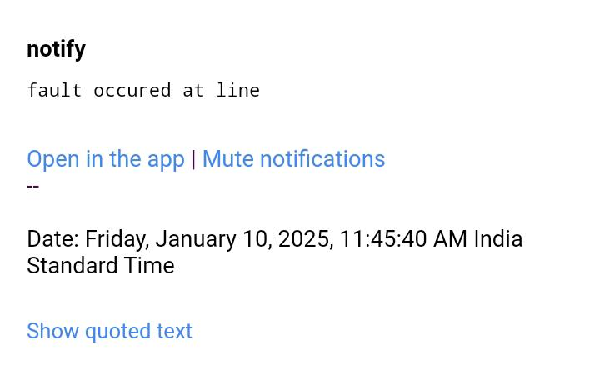

CHAPTER 8
8.CONCLUSION

8.1 Project Conclusion:
The conclusion of a 3-Phase Fault Detector Using IoT can summarize the project’s effectiveness, advantages, and future scope. Here’s a well-structured conclusion:
The implementation of a 3-phase fault detection system using IoT successfully enhances the monitoring and protection of electrical power systems. By continuously analyzing voltage and current parameters, the system can accurately detect faults such as overvoltage, undervoltage, phase loss, and short circuits. The integration of IoT technology enables real-time data transmission to cloud-based platforms, allowing remote monitoring and instant fault alerts via mobile applications or web dashboards.
The proposed Arduino and IoT-based fault detection system presents a significant advancement in monitoring overhead transmission lines. By facilitating quick fault detection and localization, the system can reduce downtime and improve the reliability of power distribution. Initial tests indicate promising results, demonstrating the feasibility of integrating modern technology into traditional power systems.
This system improves reliability, efficiency, and response time in power distribution networks, reducing the risk of damage to electrical equipment and minimizing downtime. Additionally, automation through IoT eliminates the need for manual inspections, making the system cost-effective and scalable for industrial and commercial applications.

CHAPTER 9
9. FUTURE SCOPE

  - Future addons or Updates in project:
The future scope of a Three-Phase Fault Detector using IoT is promising due to advancements in smart grid technology, automation, and AI-driven analytics. Here are some key future prospects:
1. Smart Grid Integration: IoT-enabled fault detectors can seamlessly integrate with smart grids, enabling real-time monitoring and automated response mechanisms. Helps in predictive maintenance by analyzing historical data and detecting faults before they occur.
2. AI and Machine Learning Enhancement: AI-driven algorithms can enhance fault detection accuracy by distinguishing between temporary and permanent faults. Machine learning models can predict faults based on weather conditions, load variations, and power quality analysis.
3. Remote Monitoring and Control: With 5G and edge computing, fault data can be processed in real-time, reducing latency in detecting and responding to faults. Utilities can remotely analyze fault conditions and take immediate corrective actions.
4. Energy Efficiency and Cost Reduction: Early fault detection reduces downtime, maintenance costs, and energy wastage. Minimizes financial losses in industrial and commercial setups due to unexpected power failures.
5. Self-Healing Power Systems: Future grids may incorporate self-healing capabilities where IoT-based fault detectors automatically reroute power to minimize disruptions. Automated circuit breakers and reclosers can be activated based on IoT-based fault signals.
6. Cloud-Based Analytics and Dashboarding: IoT-enabled fault detectors can store and analyze fault data in the cloud, allowing engineers to access insights from anywhere. Dashboard-based visualization can help operators quickly identify problem areas and take corrective measures.
7. Integration with Renewable Energy Systems: IoT fault detectors can help in monitoring hybrid power systems, ensuring stable power distribution from renewable sources. Can optimize load balancing in microgrids, ensuring stable operation during faults.
8. Industrial IoT (IoT) Applications: In industries, these systems can integrate with SCADA and PLCs for automated fault responses. Useful for real-time power quality monitoring in factories and data centers.
CHAPTER 10
10.FINAL CODE & RESOURCES
The final code for the IoT-based radar project that integrates the ultrasonic sensor with the ESP8266, rotating the servo to scan the surroundings, and sending data to the Blynk platform. Additionally, resources such as libraries and references are provided for further development.
10.1 CODE
#define BLYNK_TEMPLATE_ID "TMPL3011YH3ml"
#define BLYNK_TEMPLATE_NAME "3 phase fault detection system using IOT"
#define BLYNK_AUTH_TOKEN "weZggb0ZI_eyzGtUAB87nXtp81lKMsf8"

#define BLYNK_PRINT Serial
#include <WiFi.h>
#include <WiFiClient.h>
#include <BlynkSimpleEsp32.h>

char auth[] = BLYNK_AUTH_TOKEN;
char ssid[] = "fault";
char pass[] = "threephase";

#define R 22
#define Y 23
#define B 19
#define RL 25
#define YL 26
#define BL 27
int line1, line2, line3, l1g,l2g,l3g;
void setup() {
// put your setup code here, to run once:
Blynk.begin(BLYNK_AUTH_TOKEN, ssid, pass);
pinMode(R, INPUT_PULLUP);
pinMode(Y, INPUT_PULLUP);
pinMode(B, INPUT_PULLUP);
pinMode(RL, INPUT_PULLUP);
pinMode(YL, INPUT_PULLUP);
pinMode(BL, INPUT_PULLUP);
Serial.begin(9600);
}

void loop() {
// put your main code here, to run repeatedly:
Blynk.run();
line1 = digitalRead(R);
line2 = digitalRead(Y);
line3 = digitalRead(B);
l1g=digitalRead(RL);
l2g=digitalRead(YL);
l3g=digitalRead(BL);
Serial.println(line1);
Serial.println(line2);
Serial.println(line3);
Serial.println(l1g);
Serial.println(l2g);
Serial.println(l3g);
if (line1 ==0 && line2==0)
{
Serial.println("fault occured b/w line1&lin2");
Blynk.logEvent("notify", "fault occured b/w line1&lin2");
delay(3000);

}
else if (line2==0 && line3==0)
{
Serial.println("fault occured b/w line2&line3");
Blynk.logEvent("notify", "fault occured b/w line2&lin3");
delay(3000);
}
else if (line1==0 && line3==0)
{
Serial.println("fault occured b/w line1&line3");
Blynk.logEvent("notify", "fault occured b/w line1&lin3");
delay(3000);
}
else if (line1 ==0)
{
Serial.println("line fault at line1");
Blynk.logEvent("notify", "fault occured at line");
delay(3000);
}
else if (line2==0)
{
Serial.println("Line fault at line2");
Blynk.logEvent("notify", "fault occured at line2");
delay(3000);
}
else if (line3==0)
{
Serial.println("Line fault at line3");
Blynk.logEvent("notify", "fault occured at line3");
delay(3000);
}
else if (l1g==0)
{
Serial.println("Line1-gnd fault occured");
Blynk.logEvent("notify", "fault occured b/w line1-gnd");
delay(3000);
}
else if (l2g==0)
{
Serial.println("Line2-gnd fault occured");
//Blynk.logEvent("notify", "fault occured b/w line2-gnd");
delay(3000);
}
else if (l3g==0)
{
Serial.println("Line1-gnd fault occured");
//Blynk.logEvent("notify", "fault occured b/w line3-gnd");
delay(3000);
}
else
{
Serial.println("normal");
delay(500);
}
}

10.2 Resources:
Hardware Components:
1. Current Transformers (CTs): Available at online stores like Amazon, Digi-Key, or Mouser.
2. Voltage Transformers (VTs): Available at online stores like Amazon, Digi-Key, or Mouser.
3. Microcontrollers: Arduino, Raspberry Pi, or ESP32/ESP8266 boards are popular choices.
4. Communication Modules: Wi-Fi modules like ESP8266/ESP32, GSM modules like SIM800/SIM900, or Ethernet modules like ENC28J60.
5. Sensors: Temperature, humidity, and vibration sensors are available at online stores like Amazon, Digi-Key, or Mouser.
Software Components:
1. Arduino IDE: For programming Arduino boards.
2. Raspberry Pi OS: For programming Raspberry Pi boards.
3. ESP32/ESP8266 SDK: For programming ESP32/ESP8266 boards.
4. Cloud Platforms: AWS IoT, Google Cloud IoT Core, Microsoft Azure IoT Hub, or IBM Watson IoT.
5. IoT Development Platforms: ThingSpeak, Cayenne, or Blynk.
Online Resources:
1. Instructables: Tutorials and projects on IoT and three-phase fault detection.
2. Hackster: IoT projects and tutorials, including three-phase fault detection.
3. GitHub: Open-source projects and code repositories for IoT and three-phase fault detection.
4. Reddit: r/IoT, r/Arduino, r/RaspberryPi, and r/ElectricalEngineering communities for discussion and resources.
5. YouTube: Channels like 3Blue1Brown, ElectroBOOM, and DIY Engineering for educational videos on electronics and IoT.
Research Papers:
1. "IoT-Based Three-Phase Fault Detection and Classification" by S. S. Iyer et al. (2020)
2. "Real-Time Three-Phase Fault Detection Using IoT and Machine Learning" by A. K. Singh et al. (2019)
3. "Three-Phase Fault Detection Using IoT and Cloud Computing" by M. A. El-Gammal et al. (2018)
Books:
1. "IoT Fundamentals: Networking Technologies, Protocols, and Use Cases for the Internet of Things" by David Houlding (2020)
2. "Three-Phase Electrical Power Systems: A Practical Approach" by Mohamed A. El-Sharkawi (2017)
3. "Power System Protection and Switchgear" by Badri Ram (2017)

